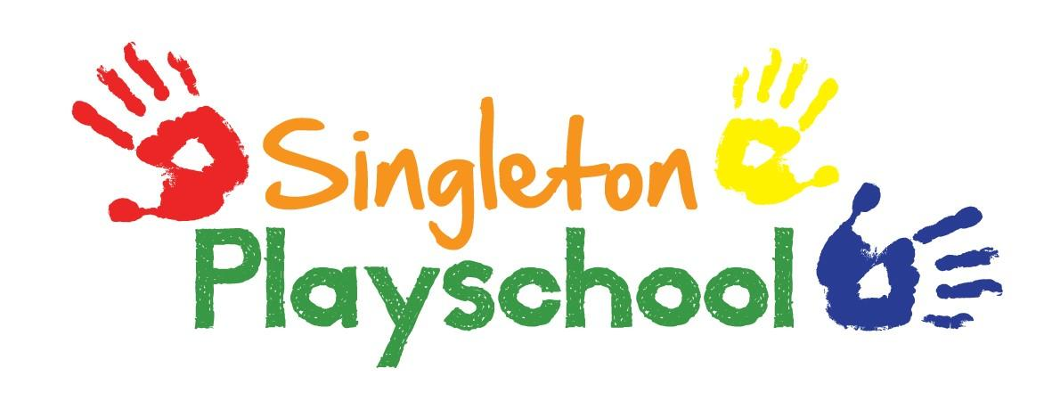
Behaviour and Discipline Policy
This policy represents the agreed principles for behaviour and discipline throughout the playschool. All playschool staff representing Singleton Playschool has agreed this policy.
Aims and expectations
It is the primary aim of Singleton Playschool that every member of the playschool feels valued and respected, and that each person is treated fairly and well. We are a caring community, whose values are built on mutual trust and respect for all. The Playschool's behaviour policy is therefore designed to support the way in which all members of the playschool can live and work together in a supportive way. It seeks to promote an environment where everyone feels happy, safe and secure and to support the key aims outlined below:
At Singleton Playschool we believe that children and adults flourish best in an ordered environment without fear of being hurt or hindered by anyone else. We aim to work towards a situation in which children can develop self-discipline and self-esteem, where their respect for others to ensure everyone knows what is expected of them and children are free to develop their learning in an atmosphere of mutual respect and encouragement.
In order to achieve this:
- Different ways of dealing with unsociable behaviour are used and this is regularly discussed and agreed within the playschool and explained to all newcomers, both children and adults.
- Appropriate methods are implemented to manage children’s behaviour including distraction, praise and reward and excellent playschool-home links.
- Children are given opportunities to show appropriate behaviour. In the unlikely situation of any unwanted behaviour continuing they are given time to ‘calm down’ with an adult. The parents would be informed about the inappropriate behaviour at the end of the session.
- All adults caring for children in Singleton Playschool will ensure that the ideas of the playschool are applied consistently, so those children have the security of knowing what to expect and can build up useful habits of behaviour. It has to be remembered that we are not born knowing how to share and play co-operatively and the children need not only to be told but also to learn by example.
- In case of serious behaviour such as bullying, racial or other abuse, the unacceptability of the behaviour and attitudes will be made clear immediately, but by means of explanations rather than personal blame. Again this would be explained to parents at the end of the session.
- All adults will be a positive role model for children with regard to friendliness, care and courtesy. We praise the children constantly for positive behaviour. The playschool expects every member of their community to behave in a considerate way towards others.
- In any case of misbehaviour, it will always be made clear to the child or children in question it is that the behaviour and not the child that is unwelcome.
- Adults in the Playschool will praise and endorse desirable behaviour such as helpfulness, kindness and willingness to share. The Playschool uses reward stickers for good/kind behaviour.
- As a team we will take positive steps to avoid a situation in which children receive adult attention only in return for undesirable behaviour.
- Adults in the Playschool will make themselves aware of and respect a range of cultural expectations regarding interactions between people.

When children behave in unacceptable ways:
- Any problems will be handled in a developmentally appropriate fashion, respecting individual children’s level of understanding and maturity. If a child smacks or hurts another child or adult, a member of staff will explain to the child what they have done wrong and possibly remove them from the situation. If a child is displaying any other forms of inappropriate behaviour with the risk of hurting themselves, others around them or the Playschool environment he or she will be told 3 times that this action is inappropriate and then removed from the situation as stated previously.

- We always encourage children to say they are sorry. Children will never be sent out of the room or left unattended in any situation.

- Recurring problems will be tackled by the whole Playschool, in partnership with children and parents using objective observations to establish an understanding of the cause.

- Parents and carers will be told at the end of the session if their child has hurt another child or it has been necessary to have a ‘calm down’ time.

- Children will be constantly reassured that they are always valued as individuals even if their behaviour maybe unacceptable. We work together to solve any problems.

- Physical punishment such as smacking or shaking will never be used nor threatened.

- Restraint may be used if a child is in danger of hurting themselves or others. The parents would be informed of this action at the end of the session.

This policy aims to help children grow in a safe and secure environment, and to become positive, responsible and increasingly independent members of the Playschool community.
The Playschool rewards good behaviour, as it believes that this will develop an ethos of kindness and cooperation.
This policy is designed to promote good behaviour, rather than merely deter anti-social behaviour.
The role of parents
The Playschool collaborates actively with parents, so that children receive consistent messages about how to behave at home and at school.
Monitoring and review
The Playschool manager monitors the effectiveness of this policy on a regular basis and reports to the team on the effectiveness of the policy and, if necessary, makes recommendations for further improvements.
If deemed necessary as well as a serious concern and/or requested by a parent/carer, the Playschool will keep a record concerning individual repeated and/or increased incidents of misbehaviour for key children.

Ann Henson is the named persons responsible for Behaviour Management in the Playschool.

Reviewed & Updated December 2021

