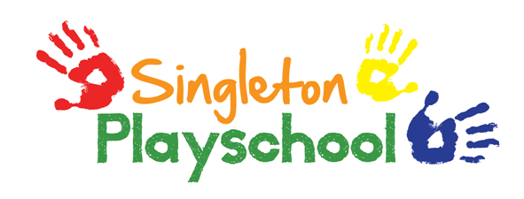
Whistleblowing Policy
Statement of Intent
The official name for whistleblowing is ‘making a disclosure in the public interest’. If staff or volunteers believe there is malpractice at Singleton Playschool they should report this by following the correct procedures. Their employment rights are protected and they cannot be victimised by the employer.
Whistleblowers are protected for public interest, to encourage people to speak out if they find malpractice in an organisation or workplace.
Malpractice could be improper, illegal or negligent behaviour by anyone who works with or within the Playschool.

When should the whistleblowing procedure be used?
To be protected as a whistleblower, a worker needs to make a ‘qualifying disclosure’ about malpractice. This could be a disclosure about:
- threats/risks to the welfare, health or safety of a child or adult
- criminal offences
- failure to comply with a legal obligation
- miscarriages of justice
- damage to the environment
- a deliberate attempt to cover up any of the above
It is the responsibility of all staff to report any improper, illegal or negligent behaviour in or connected with the Playschool.
This procedure is appropriate where a worker has genuine concerns about activities in or connected with the Playschool. It is not designed to replace or be used as an alternative to the grievance procedure.

The Playschool’s Safeguarding policy must be followed where a disclosure is made relating to the safeguarding of a child.
Whistleblowing protection applies where the person making a disclosure reasonably believes that the information disclosed, and any allegations contained in it, are substantially true. If any disclosure is made in bad faith, or concerns information which is not substantially believed to be true, or if the disclosure is made for personal gain, then such a disclosure will constitute a disciplinary offence.
If a disclosure is made in good faith, but is not confirmed by any subsequent investigation, then no action will be taken against the whistleblower.
Victimisation of an individual for raising a disclosure will be a disciplinary offence.

Action to be taken by the whistleblower
Concerns should normally be reported in the first instance to our Playschool manager, Ann Henson. If this is not possible/appropriate, they should be reported to the Chair of the Playschool Committee, Esther Jewitt.
Concerns can be reported verbally or in writing, and should include information about the malpractice and reasons for concern.
The whistleblower may nominate a colleague to be present during meetings in connection with the concerns raised.

Action to be taken by the Playschool
The Playschool must investigate any matter raised under this procedure thoroughly, promptly and confidentially.
The Singleton Playschool Committee must decide whether the matter falls within the scope of the setting’s other policies and procedures.
The Playschool Committee will investigate the matter and take action as appropriate.
If the whistleblower or anyone else connected with the setting is asked or instructed to cover up malpractice, this is itself a disciplinary offence.
If malpractice is revealed as a result of any investigation under this procedure, the setting’s disciplinary procedure will be used, in addition to any appropriate external measures.
The whistleblower will be informed of the outcome.
The Ofsted Whistleblowing Hotline (Children's social care services: raising concerns with Ofsted - GOV.UK (www.gov.uk)) is for reporting concerns about practices and procedures for the safeguarding of children and young people in local authority services.

The hotline can be contacted on 0300 123 3155 (Monday to Friday 8.00am to 6.00pm). Please see the Ofsted website (www.ofsted.gov.uk) for further advice.
---
This policy was adopted by Singleton Playschool on 17th March 2021.
Policy Review Date: 17/02/2022

Signed__________________________ Date_________
Esther Jewitt – Chair of Singleton Playschool Committee

