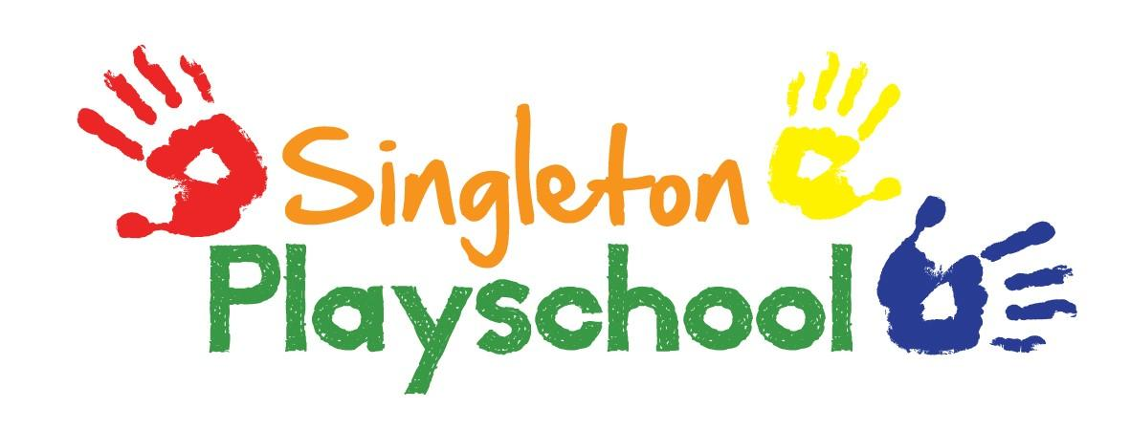
Singleton Playschool Local Offer
Our Local Offer for Children with Special Educational Needs.

1) How does the setting know my child needs extra help and what should I do if I think my child may have Special Educational Needs?
At Singleton Playschool each child has a keyworker. Their role is to develop trusting, sensitive relationships with parents and children to enable respectful sharing of information. If you have any concerns about your child’s development you can ask for a time when you can discuss this in private with them. Reports from health care professionals, such as health visitors or speech and language therapists, identify your child’s individual needs. We welcome parents and professionals sharing these reports in order to plan appropriately to meet these needs. Ongoing observational assessments are made of all the children and are linked to the Early Years Foundation Stage (EYFS) using the Early Years Outcomes guidance for ages and stages of development. This in some cases identifies individual needs. These observations will be discussed with the SENCO (Special Educational Needs Co-ordinator) Ann Henson who is also the Playschool Manager. If your child’s keyworker has identified a possible individual need, they will discuss this with you in private and enable you to plan together to support your child’s learning and development. Our SENCO will offer support and advice to your child’s keyworker and other staff in our setting. She will also liaise with other professionals to seek advice and support in identifying individual needs if necessary. Support and advice can be sought from the Area SENCO and Early Years Advisor with your permission.

2) How will you support my child?
On starting at Singleton Playschool you will be given an All About Me questionnaire to fill in about your child, to help us to gain initial information about your child’s interests, strengths and needs. Children are at the heart of all we do, and we will work with you to support your child together, listening to you as well as your child. A 2 year old progress check is carried out when the child is between 2 - 3 years old followed by regular observations, progress reviews and identified next steps according to EYFS guidelines. Observations, assessments and evaluations all contribute towards identifying individual needs and planning next steps, accessing additional support from other professionals where necessary. If your child requires it or comes to us with an Education, Health & Care Plan, our SENCO will work with any agencies involved and gain advice from the Area SENCO. She will then explain who may be involved and their roles. The SENCO will work with all staff to ensure we are providing the relevant and appropriate support. We will work in partnership with you, to identify your child’s strengths and needs while planning targets and outcomes which can be achieved together and provide you with ideas to use at home to additionally support your child.

3) How will the learning and development provision be matched to my child’s needs?

We will get to know your child before they start with us through your visits to Singleton Playschool, meetings with you and other professionals who are involved. We offer a flexible settling in routine that enables you to stay with your child until we are all comfortable that they are happy. Ongoing observational assessments will be used and linked to the EYFS ages and stages of development. Targets and next steps will be set if necessary to support the learning and development of your child. This enables planning for individual needs and learning goals. Your child’s keyworker and our SENCO will work together to make sure that the environment, routines and activities support your child’s needs and they will communicate with the rest of the staff to provide consistency and understanding within our team. We will ask for copies of assessment from other professionals before your child starts and advice from the Area SENCO will be sought with your permission and if necessary.

4) How will I know how my child is doing?

Assessment systems are in place such as the 2 year old check, ongoing observational assessments which track progress and are all linked to the EYFS ages and stages of development. You are able to view your child’s personal journal where all the observations are tracked and meet with your child’s keyworker to discuss any issues. Review meetings of your child’s progress will be carried out in partnership with you. We encourage parent involvement as helpers which would allow you to stay and help with snack time. This will enable you to see your child in the context of our Playschool, and our events throughout the year help you to build relationships with practitioners in the setting. Our open door policy means that you are always welcome to tell us how your child is doing on a daily basis and provide ongoing two way communication between us. Telephone calls can be made if parents work and are unable to bring or collect their child from Playschool. We can also provide on request, home school booklets for those parents unable to collect or drop off their child which provides information of what your child has been doing that day. This provides plenty of opportunity for you to talk to your child about their day. We also send out newsletters and post on our website to keep you up to date with what is happening in Playschool.

5) What support will there be for my child’s physical and emotional wellbeing?

Our staff are welcoming and friendly, providing an inclusive, sensitive and positive approach for your child to feel welcome into our Playschool. We promote positive behaviour by being good role models and are consistent in our day to day care of all our children. Our happy children at Playschool are testament to this. We are flexible in our routines to provide a positive environment for your child’s needs, and provide personal care, such as changing nappies, respectfully. Personal health care plans can be adopted if necessary, and staff will be trained in giving the appropriate medication for your child if required. Activities will be adapted to ensure your child is able to interact fully with their environment and are happy and content while doing so. We celebrate every child’s birthday by making cakes, playing games and balloons to take home to make them feel special and part of our Playschool family. We also appoint a Special Helper daily (every child gets a turn) who we give small tasks and responsibilities like giving out coats and bags, helping with snacks, etc. in order to encourage in them a sense of pride and feeling good about themselves.

6) What specialist services and expertise's are available at Playschool?

All staff have accessed child development training and have experience working with the Early Years age group. We have good links with our local Children & Family Centre and we can suggest support which is available through there, for example Health Visitor or Speech & Language Therapist drop in sessions. We can offer support through our Early Year Advisor, with your permission, and if your child’s needs are identified as a specific need then the team with the expertise in this area will take up the support for the child and the setting in meeting your child’s needs. Our SENCO attends network meetings to keep up to date with the latest information and news.

7) What training have the staff supporting children with SEND had or are expected to have?

Our SENCO, Ann, has former experience as a Special Needs Assistant and regularly attends SEN Briefings as well as SENCO Network meetings. A then passes on this information to other staff at monthly staff meetings. All staff are trained in Paediatric First Aid as well as Child Safeguarding and some staff have attended speech and language and behavioural training. Any other appropriate courses will be undertaken by your child’s keyworker or the SENCO if needed. Staff training records are held on file and relevant training can be viewed on request to the Playschool Manager.

8) How will my child be included in experiences away from the setting?

No child would ever be excluded from visits. We will endeavour to include parents in the planning of off-site outings to identify the strengths and needs of your child. We will invite all parents to join us on our trips. Prior to any outings, we would carry out a risk assessment to identify any dangers and how we plan to minimise any risk, taking into account the needs of all the children. We would also take along any aides or medication your child may need.

9) How accessible is the setting environment?

We aim to support families who speak English as an additional language. If you are a parent who does not have English as your first language, we can involve another family member who speaks English, or if possible arrange seek guidance and assistance from outside agencies. We welcome children who are still in nappies and those who are toilet trained. Accessible toilets and changing facilities are available and we will explain to you on your visit any limitations of our building or services. We provide multi sensory activities as part of our planning. Policies are reviewed regularly and are available for parents in the Policy folder placed below the signing in roster at the Playschool entrance.

10) How will the setting prepare and support my child joining you, transferring to a new setting or to primary school?

We would encourage short visits to Singleton Playschool where you and your child can familiarise yourselves with our setting, meet your keyworker and other members of staff. This also gives us the chance to get to know you and your family and provides the opportunity for you to share with us details of your child’s needs and the involvement of any other agencies. We can also agree with you a consistent approach to ensure the continuity of care for your child. This can also be done in a meeting before your child starts if you prefer. We could meet with other professionals, for example health care professionals to put in place transition planning/health care plan, or to seek relevant training before your child starts.

We can hold a transition meeting at your convenience, to plan transition for your child into their new setting, giving the new setting time to make necessary plans for any changes they may need to make, sharing targets on your child’s ILPP’s, and any other information that may be relevant to your child. It may also be possible to arrange for your child’s keyworker to attend settling in sessions at your child’s new setting with them, to help promote a smooth transition.

11) How are the settings resources allocated and matched to children’s special educational needs?

If specific resources are required to meet a child’s individual needs, we can apply to access funding from the local authority or Children & Family Centre. Our resources are open-ended so that children of all ages and abilities can learn from them. However resources to meet specific needs would be acquired, as far as possible, whenever they are needed.

12) How is the decision made about how much support my child will receive?

Through the observation process linked to the EYFS ages and stages of development and in discussion with you we will identify what support is required. Extra support will be put in place if necessary with the aim of enabling your child to become independent within their environment. Ongoing partnerships with you, other professionals and ourselves will support the decision making process. Our SENCO will give advice on meeting your child’s needs within our playschool in consultation with you and other professionals, where necessary and with your permission. Reports from health care professionals and other professionals who are working with your child will be used to plan support within the setting. The Area SENCO, the Early Year Advisor or other professionals working with our SENCO will support the decision making process to plan targets on the ILPP. The ILPP will be written with you and will include how you can support your child at home. Monthly staff meetings within the setting will ensure all staff working with your child knows your child’s strengths and needs and how to support them.

13) How will I be involved in discussions about and planning for my child’s education?

We encourage you to be involved from the first visits to Singleton Playschool. Your child’s strengths, needs, likes and dislikes are discussed at this time to help us make the settling in process go smoothly. You are able to volunteer to help in sessions as snack time helper if you would like to. This can be useful for you to see your child in Playschool and take the opportunity to identify what you like or what you think does not work for your child and discuss this with the keyworker or SENCO. You are involved in identifying needs, information sharing, identifying targets and next steps to focus on at home and in our setting and reviewing progress toward these targets at ILPP review meetings. Your permission will be sought before involving outside agencies.

14) Who can I contact for further information?

Your child’s keyworker is your first point of contact if you would like to discuss your child’s needs, although you can always speak to any member of staff as we work closely with all the children and continually share information on a daily basis. We are able to offer advice about other professionals who will be able to support your child, such as the Families Information Service, Children & Family Centre, health visitors, speech and language therapists and the inclusion officer for our area, and can access support from the Area SENCO, and Early Years Advisor with your permission. If your child’s need has been referred to a specific team, we will support you in accessing support from them. Our Playschool Manager is our designated person for behaviour management and can offer advice about how to cope with unwanted behaviour. If at any time you are unhappy with an aspect of our provision or practice we would ask that you come to us to discuss the matter to see if it can be resolved. If you are still unhappy, our Complaints procedure can be found in the Policies folder placed below the signing in book at the entrance.

Further information on all the services available including education, health, social care, support services and leisure, can be found on the Local Offer website via the link below:- https://www.westsussex.gov.uk/education-children-and-families/special-educational-needs-and-disability-send/send-local-offer/

