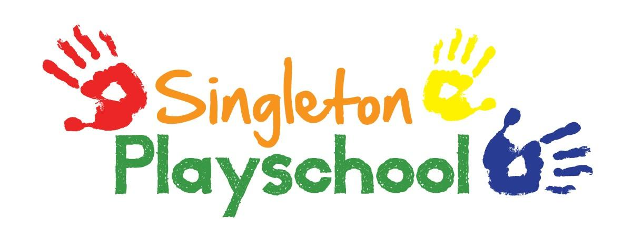
Encouraging Independence Policy

- We aim to encourage children to be independent in all activities.

- When supporting children staff should be aware to keep assistance to a minimum.

- Children should find their own peg with their names labelled and hang their coats and bags themselves as they come into playschool.

- Children are encouraged to help tidy up and return toys and equipment to their original places when finished playing with them.

- Creative activities should be resourced, set up and explained, but children should be allowed to paint/stick etc as they decide, even if it does not follow what staff had in mind.

- Children are able to choose colours for painting and pour their own paints supervised closely by staff to ensure not too much is used.

- At snack time, children will collect their own bowls and cups, pour their own drinks and take pieces of fruit each by themselves (of course, younger children may need more support to do this).

- At the end of snack time, children will carry their own bowls and cups and place them in the sink.

Reviewed and Updated September 2021

