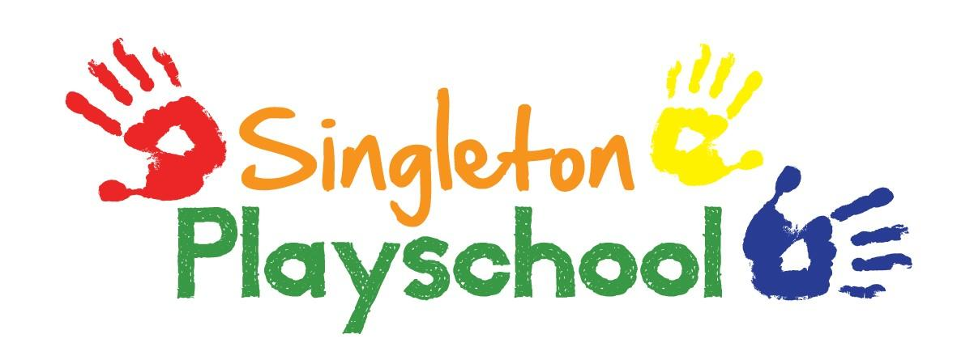
Equal Opportunities Policy

“A policy on equal opportunities for children and adults encompassing sex, race, and disability which promotes an understanding of a cultural and physical diversity and challenges stereotypes and which is responsive to local needs.”

At Singleton Playschool we aim to:

- Ensure that all children are given an equal chance to take advantage of the range of experiences on offer in the Playschool and that all children feel equally valued as part of the group.

- For staff to recognise that effective learning can only take place in an atmosphere of mutual trust and respect, that children need to feel proud of themselves and of their families, valued for what they are and feel competent that they can achieve.

- Acknowledge children’s different backgrounds through the provision of resources and materials e.g. computer tablets, posters, books, home corner, etc.

- Share information about and respect different cultures, religion, languages and community experiences - stressing similarities and celebrating differences.

Positive attitudes to gender, equality, cultural diversity and special educational needs are actively promoted.

Within the Playschool children and staff demonstrate respect for individuals and discourage stereotyped attitudes and behaviour. Staff intervene if children demonstrate through either their actions or their conversations, that their attitudes are biased.

The full range of activities and learning experiences are available to all children. Staff are aware that some children may need extra support to access an activity e.g. using construction equipment and some children may need extra support to develop their finer skills.

Reviewed and Updated September 2021

