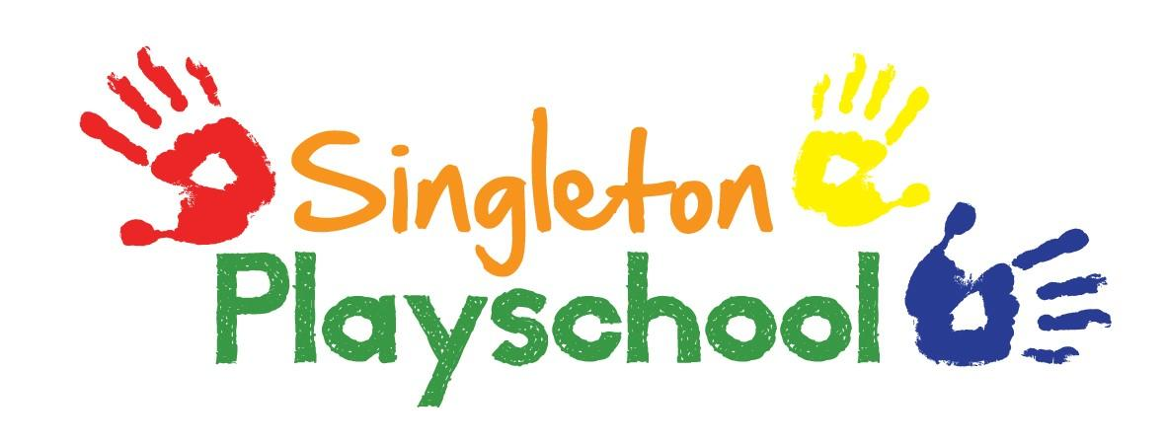
Healthy Eating Policy
At Singleton Playschool we regard snack and lunch times as an important part of the children’s day. Eating represents a social time for children and adults and helps children to learn about healthy eating. To help us comply with government initiatives and for the general well-being of the children, we adhere to the following guidelines:
• At snack time, we aim to provide healthy and nutritious food which meets the children’s individual dietary needs.
• For the lunch club sessions, children are expected to bring a balanced packed lunch with them.
We follow the procedures below to promote healthy eating at our Playschool:
• Prior to a child attending Playschool, we enquire about his/her medical, cultural and/or dietary needs including any known allergies. This information is recorded on a registration form and signed by parents/carers. We ask that parents advise the playschool of any changes to their children’s dietary needs including allergies.
• To ensure continuity of care, we display current information about individual children’s dietary needs so that all staff and volunteers are fully informed about them.
• We aim to ensure that children receive only food and drink that is consistent with their dietary needs and preferences as well as their parents’ wishes.
• In order to protect children with food allergies, we discourage children from sharing and swapping their food from their lunchboxes with one another.
• Through discussion with parents and research reading by staff, we obtain information about the dietary rules of the religious groups to which children and their parents belong, of vegetarians, vegans and about food allergies and intolerances. We take account of this information in the provision of food and drinks.
• We organise snack and lunch times so that they are social occasions in which children and staff participate.
• We have fresh drinking water available for the children throughout each session. We inform the children about how to obtain the water and help them if necessary.
• We inform parents of our policy on healthy eating.
Snack time
Mid-morning snacks include fresh fruit and/or vegetables.
A choice of fresh milk or water is supplied to drink.
Lunch club
We ask parents to provide a healthy balanced lunch for their children.
Avoid including any kind of sweets and chocolate bars.
Cooking and special occasions
Special celebrations such as children’s birthdays, multi-cultural festivals or sensory tasting activities in line with current themes may allow for small amounts of food to be tasted. Cooking activities will be a mixture of healthy foods or treats which we will use to discuss and then send home for parents to decide if their children are able to eat them.

Reviewed and Updated September 2021

