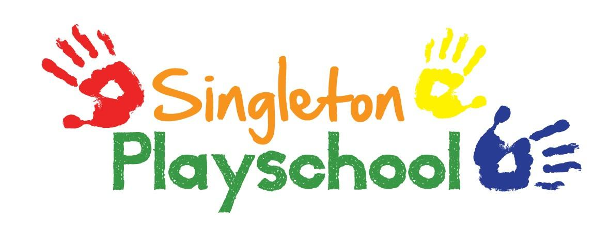
Code of Conduct & Behaviour for Staff & Volunteers

In our Playschool we pride ourselves on being caring and open with children, parents, staff and volunteers. When working with pre-school children it is very important that they have a caring environment where the use of facial expressions and a hug for reassurance is of great importance, but these must be executed in an appropriate way at all times.

Here are a few guidelines to avoid inappropriate conduct:

- Staff should avoid initiating physical contact with children.

- Avoid hugging a child unless for reassurance i.e. (after a fall, feeling unwell, missing a parent). Never initiate kissing and always discourage the child from this kind of behaviour.

- Avoid intrusive play i.e. (tickling, rough and tumble). If at any time physical contact is offered by the child, try to cease it as early as possible without the child feeling rejected.

- Ensure that the cloakroom door remains open when a member of staff is supporting a child or changing a nappy.

- If a child persists with inappropriate contact, the matter should be brought to the attention of other staff; Chair of the Committee, a plan of action will be discussed in confidence.

- At no time will staff/volunteers, members of the Committee or parents be left alone with any children.

- At no time will staff/volunteers, members of the Committee take any child back to their home.

- Personal mobile phones should not be used within the Playschool. Absolutely no photos should be taken on mobile phones of the children in the Playschool.

At all times relationships between Playschool personnel should be based on respect and honesty. All employees will be expected to contribute and take responsibility to ensure a positive working environment and to conduct themselves accordingly.

Reviewed and Updated September 2021

