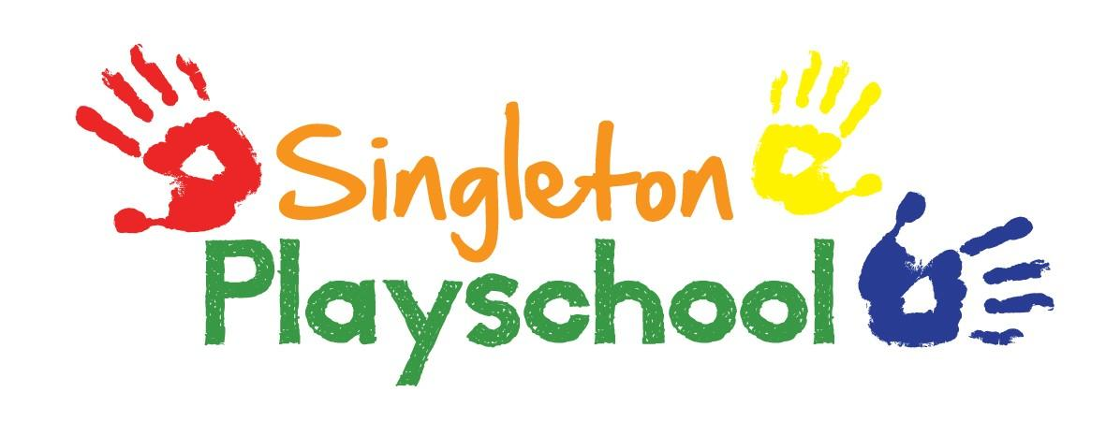
Late and Non-Payment of Fees Policy
Singleton Playschool will try to avoid any situation which would lead to a dispute between the Playschool and a parent over the late payment of, or in extreme cases, non-payment of fees.
The parents must understand that non-payment of fees may jeopardise their child’s place. If fees are not paid and there is no agreement to settle the invoice, where a child is accessing funded sessions, the child will only attend for 15/30 hours per week.
We accept payments to our Playschool bank account, and on occasions in cash.
Invoices are issued at the beginning of each half term, please pay within two weeks.
If the payment has not been settled in full within four weeks, the Playschool will send out a reminder.
After eight weeks of non-payment, court proceedings will be initiated. All legal and court costs will be included in the final bill amount outstanding including any tracing fees.
If parents’ at any time experience payment difficulties, please speak to the Playschool Manager, who will endeavour to help with any situation.
If the child no longer requires the place, the parents must agree to give one month notice of their intention to leave and should understand that they will be required to pay the fees due during the whole notice period (4 weeks).
The fees may be subject to periodic reviews, increases will be notified at least one month in advance.

Policy Adopted December 2021

