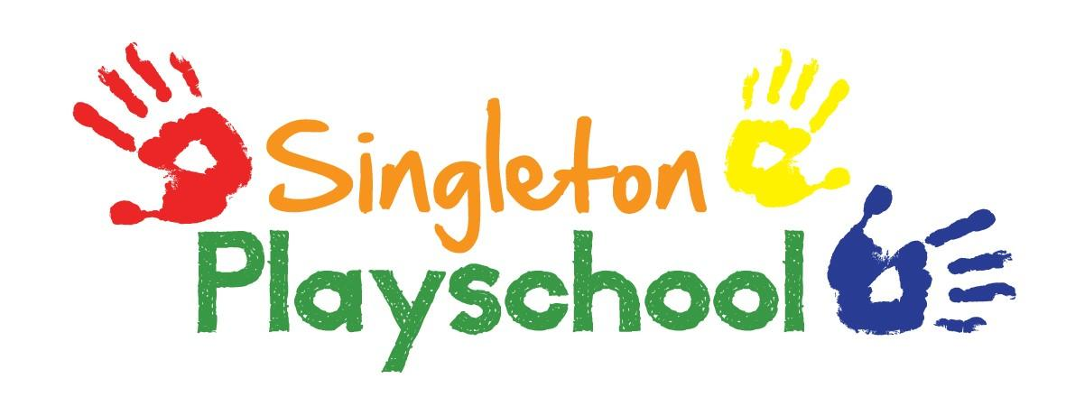
Health & Hygiene Policy

At Singleton Playschool we aim to promote a healthy lifestyle and a high standard
of hygiene and safety as part of the daily provision.

Health
Food
- We encourage parents to bring in nutritious and healthy snacks and lunches for children to eat.
- When cooking with children as an activity, the adults will provide healthy, wholesome food, promoting and extending the children’s understanding of healthy eating.

Outdoor play
- Children will have the opportunity to play daily in the fresh air throughout the year.
- Staff are aware of the dangers of over exposure to the sun’s rays; activities are planned in shaded areas. The children are provided with sun hats and parents are encouraged to dress children in clothes to protect arms e.g. shirts, and to provide sun cream.
- All measures will be taken to ensure that the activities and equipment are safe and fully supervised by staff both indoors and out.

Illness
- Parents are asked to keep their children at home if they have any infection.
- Parents are asked not to bring a child to the group after suffering vomiting or diarrhoea, for at least 48 hours following the last symptoms.
- Cuts or sores, on adult or child, will need to be covered up with a plaster or suitable dressing.

Prescribed medication
- It would be expected that the child’s parents would administer any prescribed medication.
- A full course of antibiotics should be completed before a child returns to the playschool.
- If medication needs to be administered, the medicine should be clearly labelled with the child’s name, dosage, time, and any other instructions.
- The medication book will be available, to include the child’s name, time of medication, date and time, by whom is to administer and their signature and the signature of the parent.
- The same procedure will be followed for a child on regular medication (please also see Drugs & Medication Administration Policy).

Hygiene
To prevent the spread of infection, adults in the group will ensure that the following good practices and procedures are followed:
- Hands washed after using the toilet.
- Hand washing prior to eating, drinking and cooking activities.
- Children encouraged to blow and wipe their own nose, with soiled tissues being disposed of.
- Children encouraged to put their hand in front of their mouth when coughing or sneezing.
- Paper towels used and disposed of hygienically.

Body fluids- clearing and cleaning
- Disposable gloves and aprons are to be worn at all times when clearing up blood, vomit, urine and faeces.
- Any contaminated hard surface to be cleaned with bleach, diluted to the manufactures directions.
- Contaminated fabrics with body fluids should be washed in hot soapy water then placed in a polythene bag in which they can be taken home.
- Contaminated water must be flushed down the toilet.

All staff will follow the current legislation when handling food:

- Always wash hands under running water before handling food.
- Not to be handling food or preparation if suffering from any infectious/contagious illness or skin trouble.
- Never cough or sneeze over food: if this should occur, food should be disposed of.
- Wash fresh fruit and vegetables thoroughly before use.
- Use different cleaning cloths in toilet and kitchen area and separate cloths for cleaning up after craft activities.
- Keep food refrigerated.
- Ensure waste is disposed of appropriately.
- Tea towels will be washed at the end of each session.
- All utensils will be washed and stored in a cupboard, drawer or container.
Reviewed and Updated September 2021

