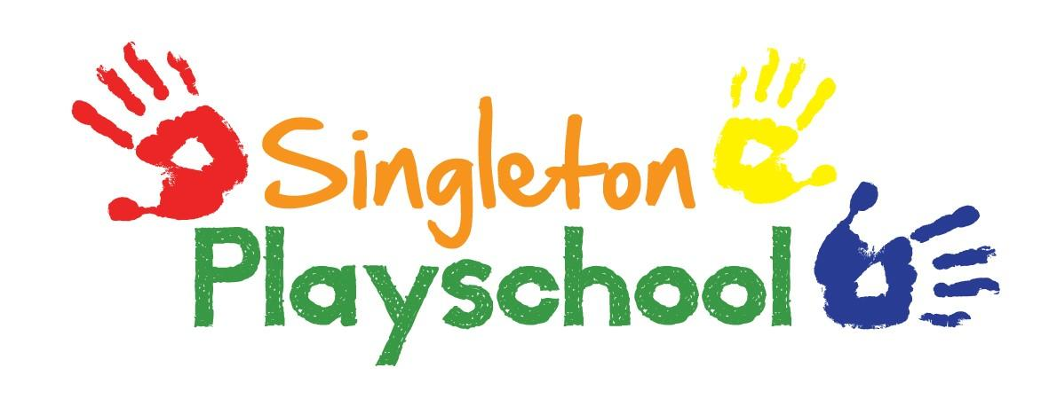
Administering Drugs or Medicines to a Child

The drug or medicine must:

- Have been prescribed by the child’s own medical practitioner
- Be kept in a secure place with access only by authorised persons
- Be clearly labelled with the child’s name

The Playschool must have:

- A letter of authorisation from the parent/carer
- Information from the child’s medical practitioner stating what condition the drug is for and its name, how and when it should be administered and any other relevant information.

Drugs and medicines register must be kept of:

- The child’s name
- Date and time of administration
- Type of drug or medicine administered
- Dosage
- Name and signature of persons administering the drug or medicine
- Name and signature of witness
- Time of notification to parent where emergency administration of a drug or medicine is given to the child

Who can administer drugs or medicine?

A qualified nurse or First Aider, witnessed by another trained First Aider or qualified person in charge.

Reviewed and Updated September 2021

