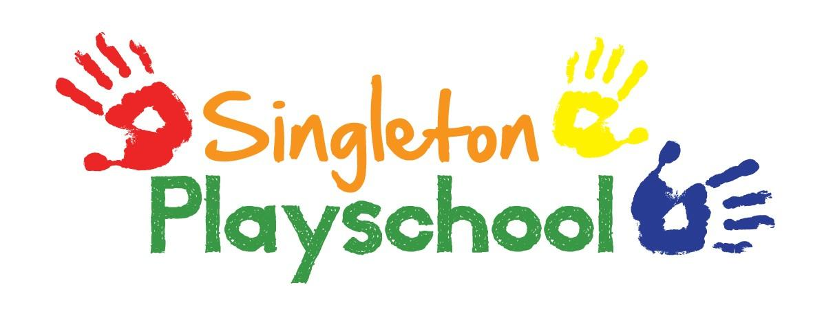
Curriculum Planning Policy

Our group is registered with The Early Years OFSTED Inspection Unit, as providers of childcare.

Curriculum
Within a planned programme we take care to provide activities which use equipment appropriate to the age and stage of development of the children, to stimulate their interest, encourage investigation and enable children to practise existing skills and to develop new ones. Children can attend our group from the age of 2. We aim to meet the needs of these younger children by being aware of the different stages of development. We cover all seven strands of the EYFS, which covers the age of birth to the end of the reception year in school. These are:
- Personal, Social and Emotional Development.
- Physical Development
- Communication and Language
- Literacy
- Mathematics
- Understanding the World
- Expressive Arts and Design

High priority is given to personal and social development. Activities are offered to support these areas through interests relevant to the child, building on their existing knowledge and extending it to wider subjects. Staff are involved in planning and recording children’s progress by evaluation of activities and detailed observation of children’s play. Observations are recorded on our online learning journals and tracker sheets kept for each child to ensure they are making progress in their learning.

We encourage children to:
- Develop social skills, taking turns, sharing, listening to others and collaborating.
- Be independent, put on their coats and make considered choices.
- Engage in imaginative play and to take on roles.
- Be creative through art and music.
- Experiment with different materials both natural and man-made.
- Have a caring attitude.
- Develop finer manipulative skills and larger motor skills such as balance, skipping, and climbing.
- Become good listeners, develop language and extend vocabulary.
- Use number, shape, size, sequences; and to question, estimate and compare.

Reviewed and Updated September 2021

