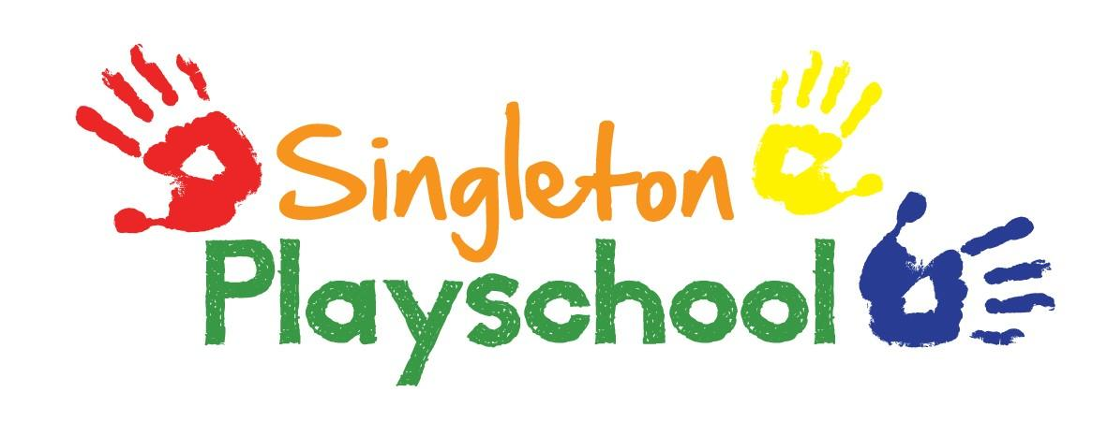
Admissions Policy

It is our aim at Singleton Playschool to provide sustainable, affordable, accessible childcare to all sectors of the local community.

In order to do this we operate the following policy:

- The Playschool is open to every family in the community and we ensure that its existence is advertised in places accessible to all sections of the community.
- We ensure that information about our Playschool is regularly communicated by providing half-termly newsletters to parents/carers including updating information on our website and on Social Media.
- We welcome children regardless of their gender, special educational needs, disabilities, background, religion, ethnicity or competence in spoken English.
- We monitor gender and ethnic background of children joining our Playschool so no accidental discrimination is taking place.
- We arrange our waiting list in birth order - In addition we may also take into account the following; siblings already attending the Playschool & length of time on the waiting list.
- No more than 15 children may attend at any one session.
- Children are admitted when they reach 2 years old, dependent upon the availability of space, and readiness of the individual child to stay happily within the group. A child can remain with us until the term before his or her 5th birthday.
- Parents/carers are advised to enrol their child for at least a minimum of 2 sessions per week to encourage settling in & a familiar routine. Only in exceptional circumstances will we admit a child for only one session per week.
- Parents/carers are encouraged to visit with their child shortly before admission is due, and should be prepared to stay with their child if necessary for the first few sessions. We operate a flexible admissions procedure and where appropriate a child may attend for brief periods at first; gradually building up to a full session.
- From the term following their 3rd birthday all children will be eligible for funding (Free Entitlement) which will pay for 15 hours of playschool attendance per week. If a child is to leave our setting before moving on to school, or to reduce the number of sessions attended, parents must give at least two week’s notice of the leaving date in writing. Fees will be payable (or entitlement claimed by us), until that date.
- We also offer places for 2 year old Free Entitlement funding which will also pay for 15 hours of playschool attendances per week but these are subject to eligibility – please speak to the Manager for more information and advice about applications.
- If a child is entitled to 30 hours of funding then it can be shared between ourselves and another childcare provider.
- We currently open from 8.30am to 3pm Mondays-Friday. Funded hours can be claimed in 3 hour blocks (i.e. 9-12; 12-3) up to 15 hours per week.
- Any extra sessions required beyond the funded 15 hours will be charged at £14.00 per session.
- We also offer Lunch Club from 12pm-12.30pm Mondays-Thursdays at £2.50 per session.
- ‘Early Starts’ are offered to coincide with the School’s drop off time. This is an extra cost of £3 per session and must be pre-booked.

Reviewed and Updated September 2021

