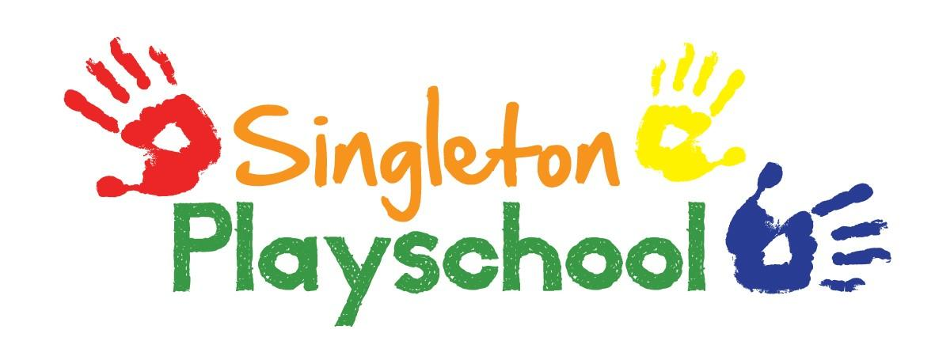
Alcohol, Drugs and Smoking Policy

Alcohol policy

We at Singleton Playschool operate a Non-Alcohol policy in our building and school grounds. If a member of staff reporting to work is smelling of alcohol or under the influence of alcohol they will be classed unfit for work and will be sent home pending a disciplinary hearing.

Drugs policy

We at Singleton Playschool operate a Non-Drug taking policy in our building and school grounds. It is also deemed that a member of staff reporting to work under the influence of non- prescription drugs is unfit to work and will be sent home pending a disciplinary hearing.

Smoking policy

We at Singleton Playschool operate a Non-Smoking policy in our building and school grounds.

Failure to comply with the above policies could result in a termination of Contract.

Reviewed and Updated September 2021

